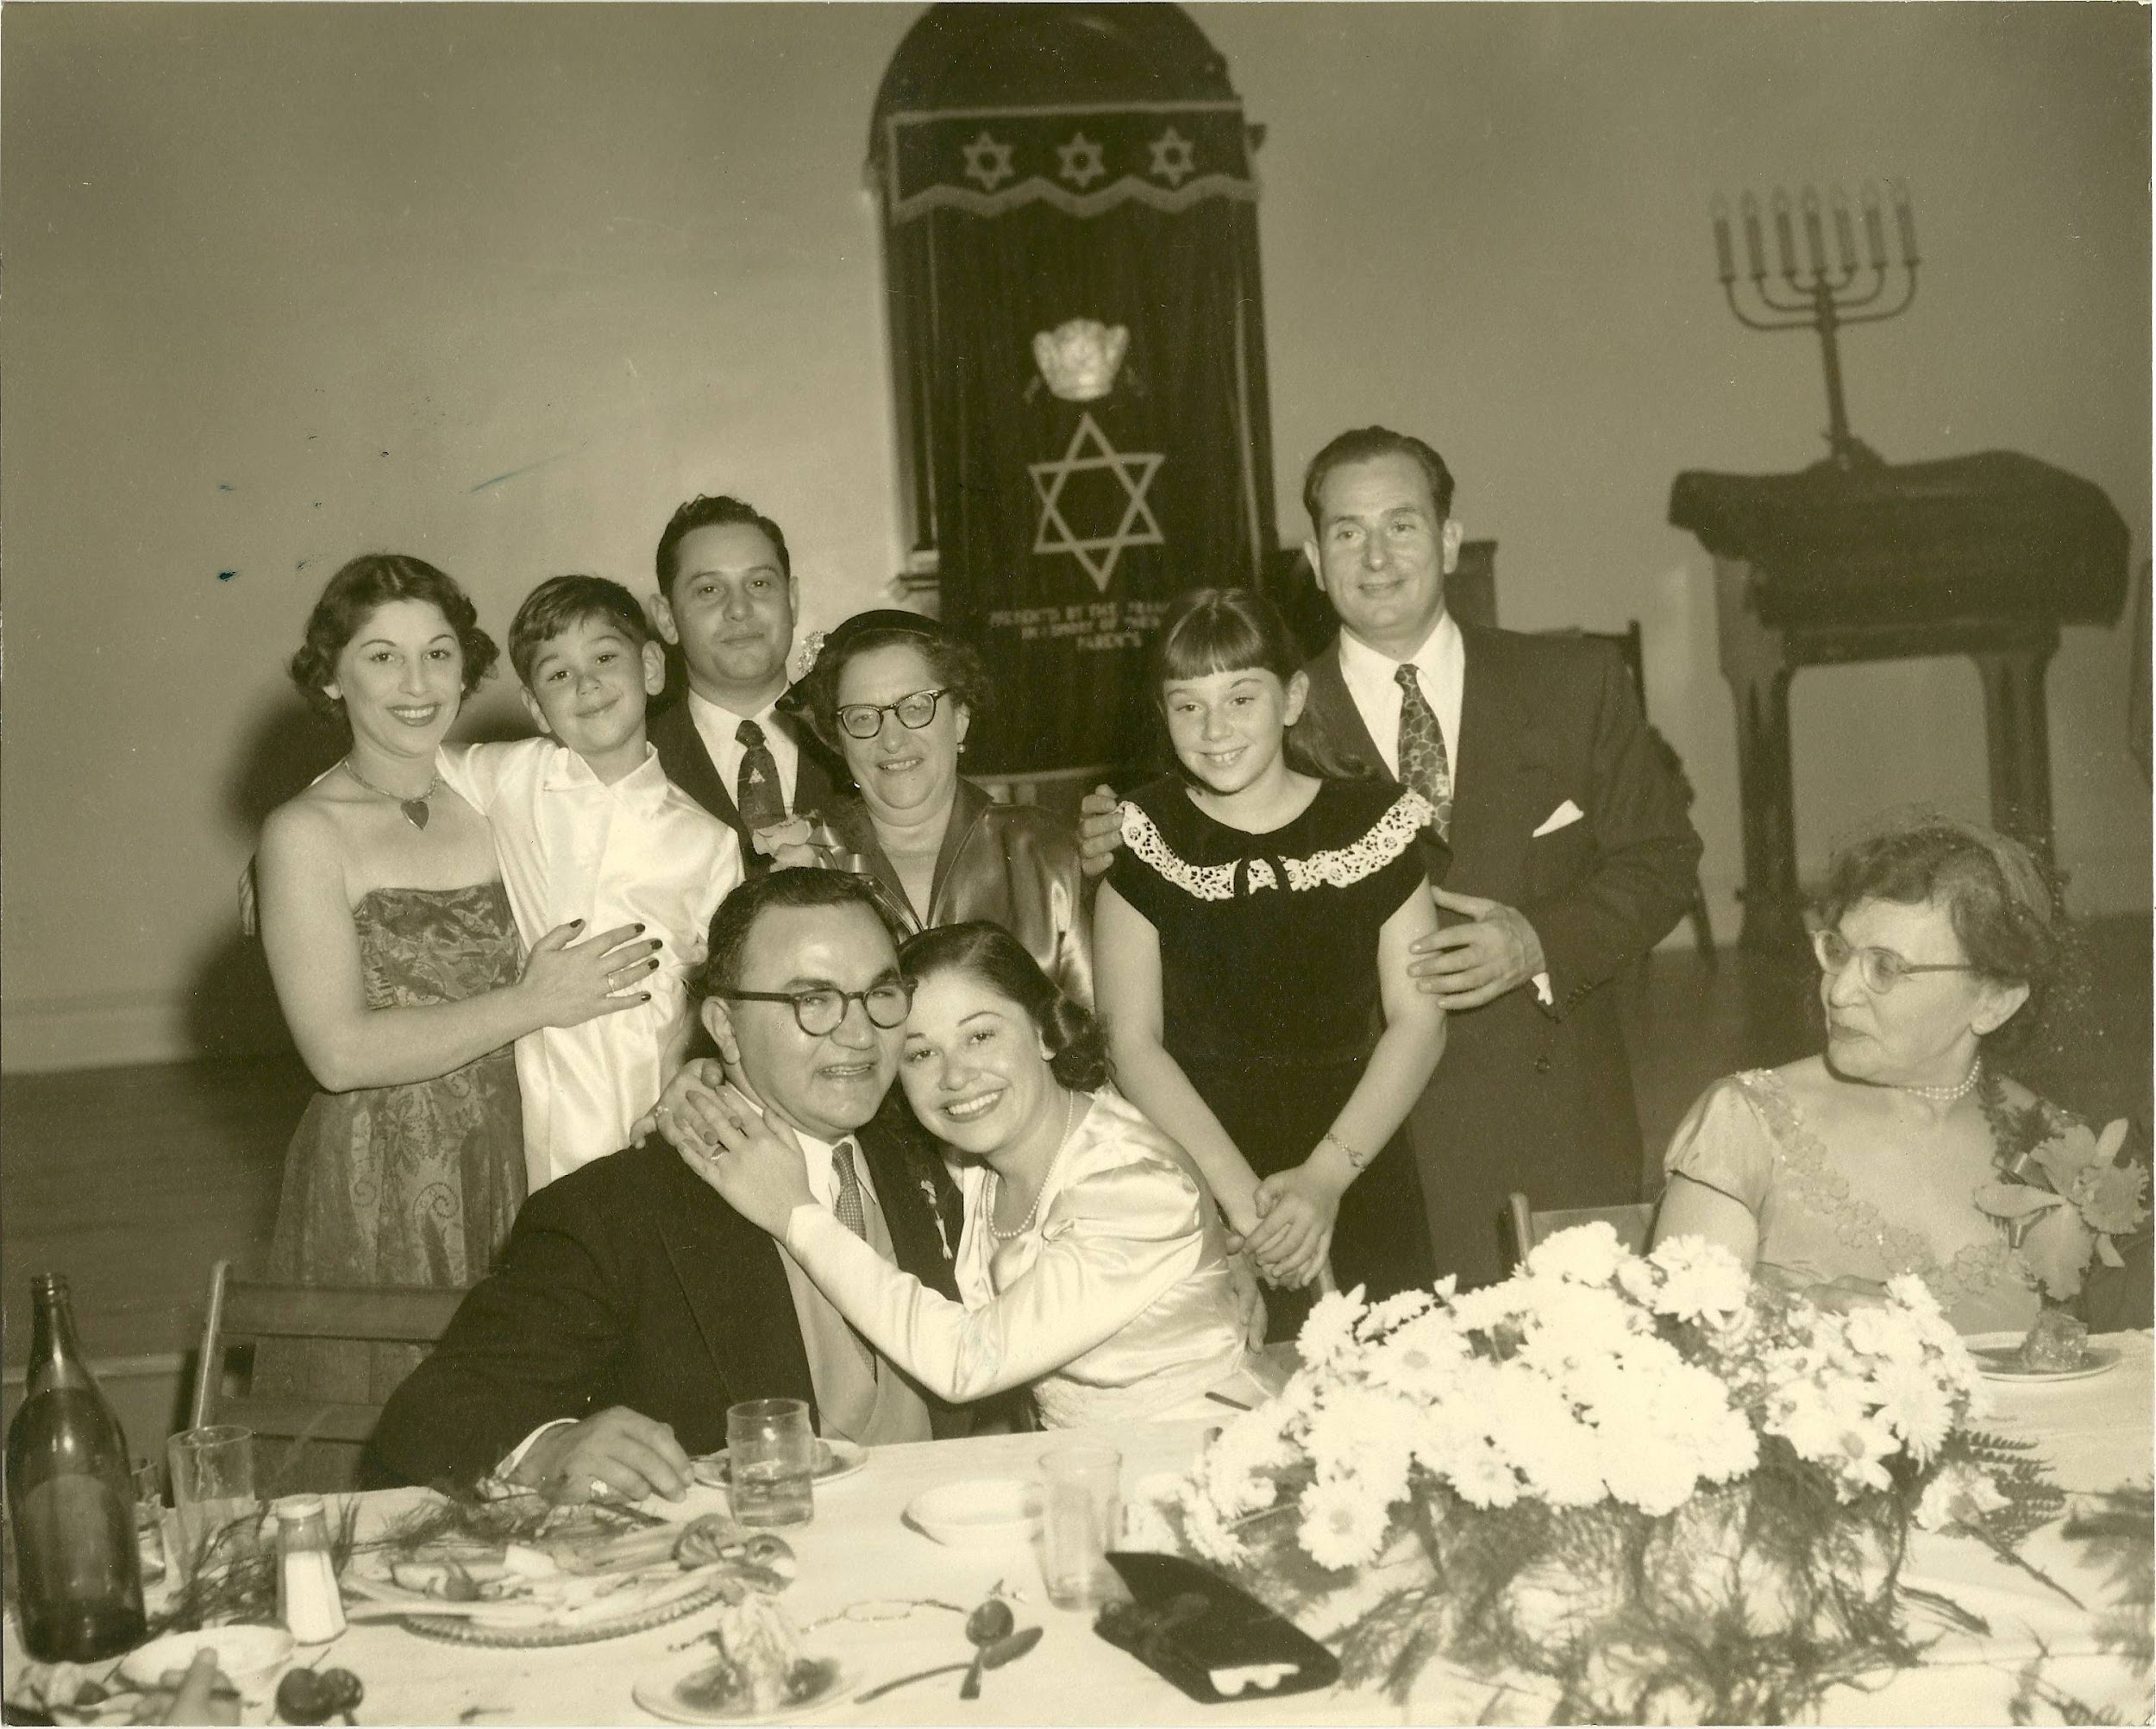

Esther Schwartz



Nathan Litt



Mildred Solomon



Bender Solomon